1. Global Text Replacement
Replace all instances of "Ville de Niamey" with "Ville de Diffa" throughout the entire platform
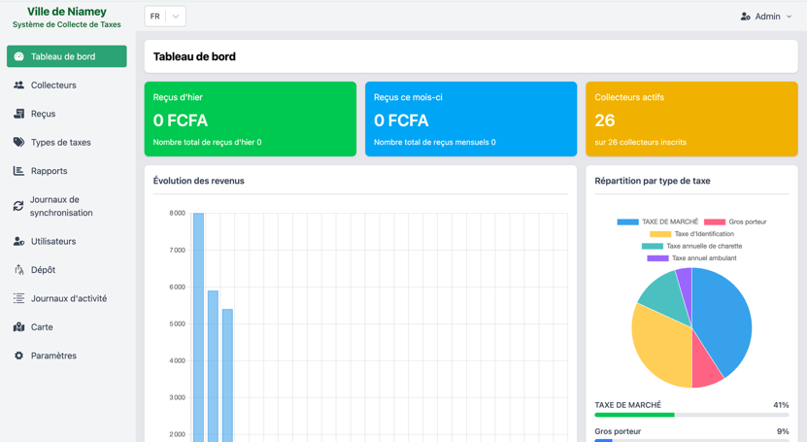
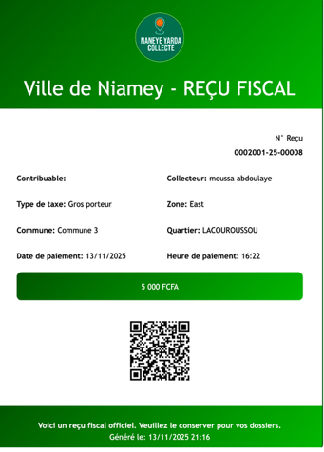
2. Collector Management
Remove the communes list since there is only one commune
Replace the current neighborhoods list with the neighborhoods provided in the attached Excel file
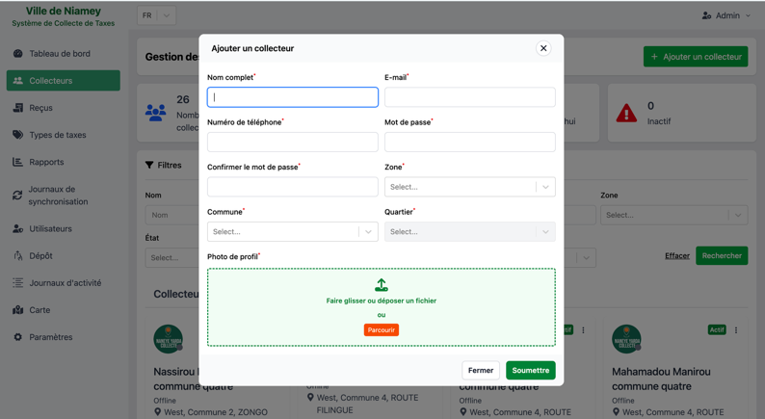
Remove the zones field as there is only one zone
3. Receipt Management
Replace the current Niamey city receipt with a Diffa city receipt
Update the receipt format to include the Diffa city logo (provided in attached file)
4. Deposit Management
Remove the submission mode field (payment method will always be cash)
After selecting a depositor, remove the following mandatory fields:
Depositor name (not necessary since it's a collector)
Depositor phone number (not necessary since it's a collector)
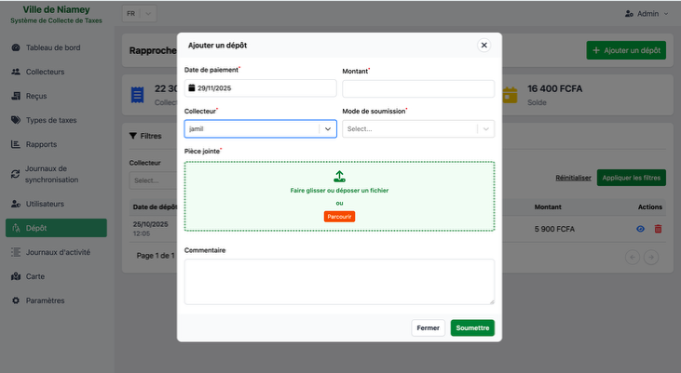
File of deposit facultative
5. Mobile Application
Remove the manual receipt number entry field
Make all receipts auto-increment so that internal receipt numbers are generated automatically without manual input
